Stratford Continuing Education Class Locations
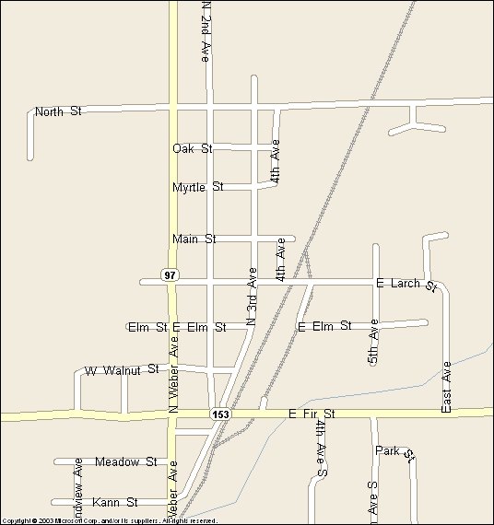
Zion Lutheran Church 213501 Legacy St
Stratford High School 211311 Legion St
6

High Sch
Stratford Elementary 213310 Legion St
Stratford Library 213201 Scholar St
5
Stratford Community Town Hall
118900 E. Larch
6

Klemme Reserve
119450 E. North St.
5
7

7

Klemme Park
213133 Legion St.

- Zion Lutheran Church
- Fellowship Hall- Park on Oak St. or in the south parking lot. Enter through the SE double-glass doors, go down the steps, to the left and to the end of the hall.

- Family Center or Gathering Space- Park in the South or East Lot and enter through the East door under the Portico. Go straight past the office. Enter thru 1st door on your right for the Family Center or go down to the end of the hall for the Gathering Space.

- Stratford High School
- In Library, Commons, or Gym Lobby Park on 3rd Ave. or in the lot northwest of the school off of 3rd Ave. Commons & Library: Enter through the bank of glass doors at the east end of the parking lot. [Entry #8] Gym Lobby: Use Entry # 10 which is just north of Entry 8.
- Rooms 62, 35, 59, 64, Gym Park in the lot south of the school. (Entry #1)
- In Gym Park in the lot south of the high school. You will enter through Door #1 or the double door on the right side of the building. Walk straight down the hallway about 1/2 way, and you will see the entrance to the gym on your left.

- Stratford Elementary
- Gym Park along 3rd Ave. or in the lots north of the schools.
off 3rd avenue. Enter through north door.

- Cafeteria Park along 3rd Ave or in the lots north of both the schools.
Enter through set of doors that is closest to 3rd Ave. (directly across from door #7 at the high school)

- Klemme Reserve
- Hwy 97 [N Weber Ave.] to North Ave.
[by Bill’s Service]. The Reserve is on the left side
of the road about ½ mile down North Ave

- Klemme Park
- Hwy 97N to Larch St., right 3-blocks to park & shelter on right
Angle park on 3rd, OR curbside on Larch

