Spencer Class Locations
Stratford Continuing Education Classes
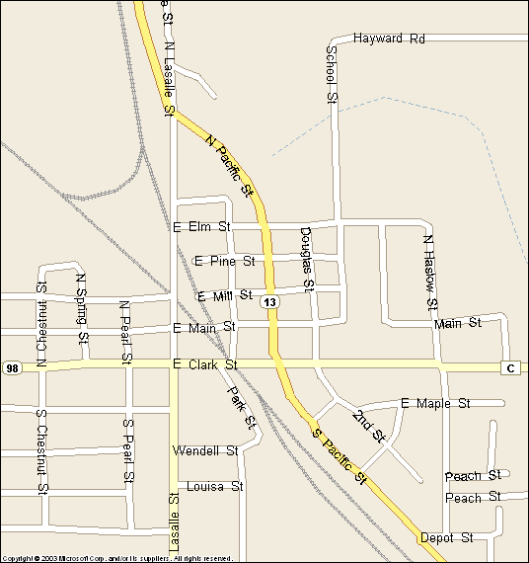

4

Trinity Evangelical
Luthern Church
109 W Clark St

Spencer High School
High Sch
300 School St.

Spencer Village Hall
High Sch
3
105 Park St.

4

NTC Spencer Campus
808 N. Pacific St/Hwy 13N

3
- Trinity Evangelical
Luthern Church
- Turn west on 98/W Clark.
- Park in church lot
-------------------------------------------
- Spencer High School
- Park on School St. or in the Lucille Tack lot to the far noth of the buildings
- Room 322 & 303 – use entrance # 22
- Gym C – use entrance #1
- Commons – use entrance #22
----------------------------------------
- Spencer Village Hall in the Municipal Building
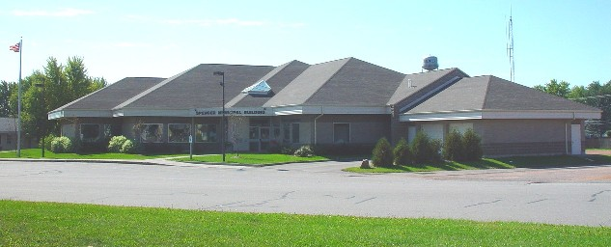
- Turn on Park St. and park in the lot behind the building. You can also enter the lot from the alley by My Brother’s Place Tavern. Enter through the West Door which faces the parking lot.
-----------------------------------------
- NTC Spencer Campus [park in campus lot and enter main door]
Go north from Spencer on 13 -- NTC Campus - eastside

[3-10-09]

